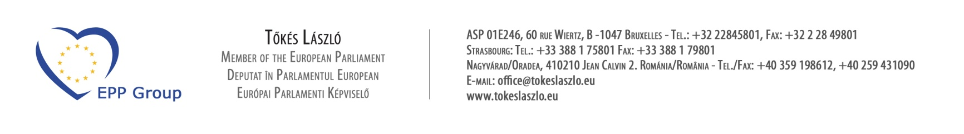

The Honorable John Kerry
Secretary of State
Independence Avenue SW
Washington, D.C. 20591
December 3, 2014

Dear Secretary Kerry,

As you may recall, a June 13, 2013 letter of twenty-one U.S. Congressmen requested that, the State Department vigorously engage the Romanian government to end the travesty of justice by failing to fully restitute properties confiscated from religious denominations after 1945. I wish to thank the State Department for closely following the Romanian court proceedings on the subject matter by having representatives of the U.S. Embassy in Bucarest attending the trials. I would like to draw your kind attention to the fact that, despite these efforts, a recent politically motivated court decision again denied fundamental rights in Romania.

On November 26, 2014 the Court of Appeals in Ploieşti, Romania upheld, in part, an earlier ruling, which in essence reconfiscated from the Reformed Church the previously restituted Székely Mikó Reformed High School property in Sepsiszentgyörgy (Sfântu Gheorghe). In addition, the court sentenced three members of the Special Committee on Church Property Restitution (SCCPR) to three years of suspended prison time, because they implemented the Law on Restitution, and returned the above property to its rightful owner, the Transylvanian Reformed Church District. This recent action is a clear violation of both the Romanian law and basic human rights.

The Communist regime in 1948 illegally confiscated 2,140 properties from four denominations in Romania ⎯ Roman Catholic, Reformed, Unitarian, and Lutheran. Properties belonging to Jewish synagogues and entities were also confiscated. Since the early 1990’s, the United States Commission on Security and Cooperation in Europe and the U.S. Embassy in Bucarest monitored the process of returning properties to these religious institutions. Unfortunately, Romania has lagged significantly behind other post-Communist countries in this regard.

In the 25 years since the fall of Communism, these churches have not regained possession of most of their properties. As of December 1, 2014, the churches have regained legal possession of only half and physical possession of only one-third of their properties. The actual church property restitution process was adversarial and designed to proceed at a slow pace. Despite the passage of numerous restitution laws, the political will to enforce them remains absent, and the process results in endless litigation and procedural delays.

In 1948 the Székely Mikó Reformed High School was confiscated from the Transylvanian Reformed Church District by the Communist government. On May 14, 2002, the building of the high school was returned to the Reformed Church. Tragicomically, the National Anti-Corruption Directorate (DNA) eight years later, in 2010, filed charges against the members of the restitution committee (SCCPR) in Romania, for returning the property to its legal owner. The Chief Prosecutor charged with “corruption” three SCCPR members including: Attila Markó, State Secretary on Minority Issues; Tamás Marosán, former legal counsel of the Transylvanian Reformed Church District; and Silviu Clim, former councilor of the Ministry of Justice.

Specifically, the three SCCPR members were accused of allegedly causing financial losses of 1.3 million RON (US$ 370,000), to the Romanian state, as a result of returning the Székely Mikó Reformed School to its original owner. The principal charge was: “misuse of official power at the expense of public interest entailing severe consequences”. Of course, in the future this poses a very significant deterrent to anyone involved in obtaining the restitution of church properties in Romania. The decision sets a very dangerous legal precedent that could result in other instances of “re-nationalization” or “reconfiscation” of previously returned church properties.

I respectfully ask and urge you that, in your discussions with the Romanian Government you request equitable, prompt, and fair restitution be provided to all religious institutions, whose properties were seized by the former Romanian Communist government, including the Székely Mikó Reformed High School. Thank you for any assistance you may provide in this matter.

Very truly yours,

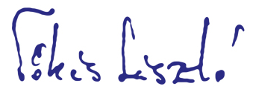
László Tőkés
Member of the European Parliament

